Reporting Template for Land Use Risk Identification (LURI)

Date of report submission
Reference document used for LURI | Historic land use cover maps from valid HCV assessment  LUCA from the New Planting Procedure (NPP)  LUCA from the Remediation and Compensation Procedure (RaCP)  Please tick the relevant box(es). You may select more than 1 if there are more than 1 reference document used in the preparation of this LURI.

- Company Information
1.1. Basic Information
Name of RPSO member
RSPO membership number
Date of joining RSPO |  | dd/mm/yyyy
Name of reporting subsidiary/management unit
Country of reporting subsidiary/management unit
Province and district of reporting subsidiary/ management unit
Total area of management unit (ha)
Georeferenced vector data indicating the legal boundaries of management units |  | Please fill in the file name, attach the maps (in jpg/png/pdf format) AND submit the files (in shp/tab/dwg format).
NPP 1st submission (if relevant) |  | dd/mm/yyyy
NPP approval date (if relevant) |  | dd/mm/yyyy
HCV assessment*  (to attach with submission) | Date conducted | dd/mm/yyyy | □ Attached?
 | Date report issued | dd/mm/yyyy
LUC assessment*  (to attach with submission) | Date conducted | dd/mm/yyyy | □ Attached?
 | Date report issued | dd/mm/yyyy

* Note: To attach the relevant report(s) that was used as reference(s) for the LURI

2. Result

Guidance: Optional actions in cases where problems occur with satellite image(s):
- Cloud coverage: Use satellite images from other dates of acquisition with cloud coverage below 20%
- Acquisition image not of good quality: Wherever possible, 1-3 months afterwards (or 6 months at the longest). The further the acquisition date, the larger the differences in land cover conditions.
Please note that the images in Section 2.1 are example(s) of the information to be provided.

2.1 Data Comparison Table
Remarks (if any):

Remote sensing image Nov 2015 (insert date of satellite image acquisition) | Land cover classification Nov 2018 | Land use risk identification Nov 2018
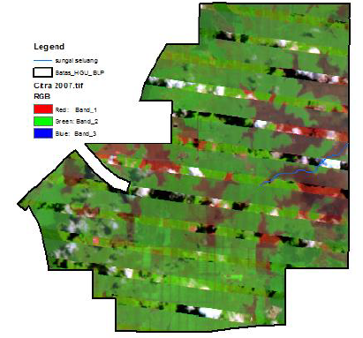 | 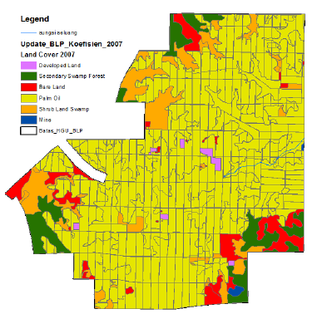

Remarks (if any):

Remote sensing image Nov 2018 (insert date of satellite image acquisition) | Land cover classification Nov 2018 | Land use risk identification Nov 2018
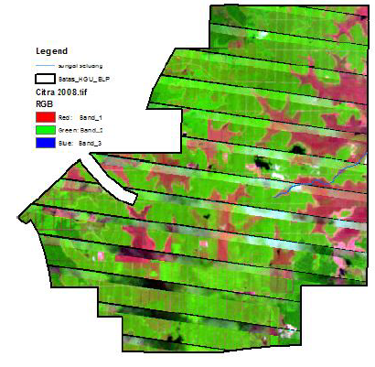 | 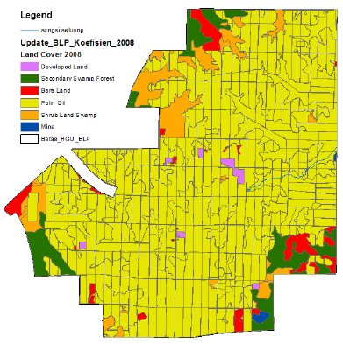

2.2 LU Risk Identification

Guidance: The land cover classification and ID in the table below serve as examples of land cover class and are not fixed nor limited to those provided. Land cover class and ID may be added and/or removed based on the classification found in the LUCA and HCV assessment of the respective area. The categorization of risk according to the land cover class are as below:

- Low risk – bare land, pasture, infrastructure, agriculture or monocrop tree plantations which have not been abandoned > 3 years.
- Risk – land cover other than those identified as ‘low risk’ or ‘No go ‘areas.
- No go areas – HCV, peat, riparian areas, steep terrain, conservation areas.

ID | Land cover class |  | Area (Ha) |  | Risk category  (low risk/risk/No go) | Total area  (Ha)
 |  |  | 2015 | 2018 |  | Risk | Low Risk | No go
R1 | Secondary Forest |  |  |  | Risk
R2 | Shrub |  |  |  | Risk
LR1 | Bare land |  |  |  | Low risk
LR2 | Oil Palm |  |  |  | Low risk
LR3 | Infrastructure |  |  |  | Low risk
LR4 | Rubber plantation |  |  |  | Low risk
HCV | HCV area |  |  |  | No go
HCVMA | HCV management area |  |  |  | No go
CSA | Conservation (e.g. peat etc.) |  |  |  | No go
Grand Total
 |  | Remarks (if any):

2.4 Geo-tagged Site Photographs
Guidance:
Geotagged photograph needs to be taken as an evidence of ground checking for each land cover class identified and reported. Geotagged photos can be captured using smartphones (guidance on the use of smartphones for geo-tagging provided below):
- iPhone: Launch Settings --> Privacy --> Location Services --> Camera --> While Using the App
- Android: Open camera app and tap on Settings. From the Settings, scroll down until you see the option “Geo tags” (or similar option) and enable it
- Tutorial to enable geotagging: https://www.youtube.com/watch?v=TpCeOkw2QdY
At least four photographs are required to ensure the entire landscape around the sample point is captured. Ideally the photos should be captured towards north, south, east and west direction.
A folder containing the images to be submitted as annexure with the corresponding photo reference ID
ID | North | South | East | West
R1
Photo ID:
Coordinates:

R2
Photo ID:
Coordinates:

LR1
Photo ID:
Coordinates:

LR2
Photo ID:
Coordinates:

LR3
Photo ID:
Coordinates:

LR4
Photo ID:
Coordinates:

2.5 Final LU Risk Identification map
Insert final map
ID | Area (Ha) |  | Remarks (if any)
 | Risk | Low Risk
R1
R2
LR1
LR2
LR3
LR4
Total

The intent of the land use risk identification is to identify “low risk” and “risk areas” in conjunction with the “Interpretation of the RSPO Principles and Criteria 2018: Indicator 7.12.2 and Annex 5” document (approved by the RSPO BoG on 12 June 2019). All risk areas identified through the LURI report must undergo a standalone HCSA assessment conducted by a registered HCSA practitioner and submitted to HCSA for peer review. Map sources and specifications shall follow the requirements of the ‘RSPO Guidance for Land Use Change Analysis (2017).
For more comprehensive guidance, please refer to ‘RSPO Guidance for Land Use Change Analysis (2017).
Please refer to the RSPO Principles and Criteria (2018) Annex 1 for the definitions of steep terrain

