Annex: Reporting Template for Land Use Change Analysis and Compensation Liability Calculation

Revised version. March 2017

Section 1: Attachments for LUC analysis report and associated files need to be submitted to the RSPO
No | Items | Additional information | Status | File name | Reviewer’s comments
1 | Digital image file format AND georeferenced vector data indicating the legal boundaries of management units, e.g. business permit/HGU/izin lokasi (Indonesia), permitted boundary (Malaysia), land title (America) | Use the latest legal boundary  File format: jpg/png/pdf AND shp/tab/dwg. |  | See Section 2
2 | Pre-processed georeferenced satellite images with suitable resolution (between 1-30 meter) for entire legal boundary for each of clearance period and additional cut-off periods | Cut-off periods: on or soon after 1 Nov 2005, 31 Nov 2007, 31 Dec 2009, 9 May 2014.  Additional cut-off periods: on or soon after the date of HCVs identified and the date of becoming RSPO member.  Latest satellite image used for survey designing, ground truthing and image validating.  File format: jpg/png/pdf AND tiff/img/ecw. |  | See Section 2
3 | Digital image file format AND georeferenced vector data of soil type in the study area | Base map for the identification of areas where planting is prohibited by RSPO P&C or by country’s specific legislation which were potentially lost.  File format: jpg/png/pdf AND shp/tab/dwg. |  | See Section 2
4 | Digital image file format AND georeferenced vector data or raster data of slope in the study area | Base map for the identification of areas where planting is prohibited by RSPO P&C or by country’s specific legislation which were potentially lost.  File format: jpg/png/pdf AND shp/tab/dwg OR grid/asc |  | See Section 2
5 | Digital image file format AND georeferenced vector data of watershed-hydrology in the study area: rivers, streams and riparian zones | Base map for the identification of areas where planting is prohibited by RSPO P&C or by country’s specific legislation which were potentially lost  File format: jpg/png/pdf AND shp/tab/dwg. |  | See Section 2
6 | Digital image file format AND georeferenced vector data of HCVs | File format: jpg/png/pdf AND shp/tab/dwg. |  | See Section 2
7 | Digital image file format AND georeferenced vector data of sampling locations | File format: jpg/png/pdf AND shp/tab/dwg. |  | See Section 2
8 | Digital image file format AND georeferenced vector data to proof whether there is potential loss of social HCVs (4-6) or not | File format: jpg/png/pdf AND shp/tab/dwg. |  | See Section 2
9 | Digital image file format AND georeferenced vector data to proof whether there is any clearance in prohibited areas or not: riparian zones, steep slope, peat | File format: jpg/png/pdf AND shp/tab/dwg. |  | See Section 2
10 | Raw land cover maps in vector data format and digital image file format prior division into the according vegetation coefficients for each of clearance period and additional cut-off periods | Cut-off periods: on or soon after 1 Nov 2005, 31 Nov 2007, 31 Dec 2009, 9 May 2014.  Additional cut-off periods: on or soon after the date of HCVs identified, becoming RSPO member.  File format: shp/tab/dwg AND jpg/png/pdf. |  | See Section 2
11 | Processed land cover maps in vector data format AND digital image file format after division into the according vegetation coefficients (1.0, 0.7, 0.4, 0) for each of clearance period and additional cut-off periods. Please refer to the Remediation and Compensation Procedure revised document, November 2015. | Cut-off periods: on or soon after 1 Nov 2005, 31 Nov 2007, 31 Dec 2009, 9 May 2014.  Additional cut-off periods: on or soon after the date of HCVs identified, becoming RSPO member.  Please add all information to each attribute table of the vector data (example of requirement information are listed in Section 2).  File format: shp/tab/dwg AND jpg / png / pdf. |  | See Section 2
12 | Processed land clearance data (corporate and non-corporate) in vector and analog data format | File format: shp/tab/dwg AND jpg / png / pdf. |  | See Section 2
13 | Company development plan per year for each management unit. | File format: xls/doc/pdf. |  | See Section 2

Section 2. Data management for files submitted to the RSPO
No. | Required additional information | Example
1. | Data grouping:  All data submitted to the RSPO must be organized in separate folders according to the data type:  - Additional data: must contain all documents required for additional information regarding LUC analysis, including all required maps.  - Document: must contain LUC analysis report as mentioned in the reporting annex, including all required maps.  - Raster data: containing all data in raster format.  - Vector data: containing all data in vector format. | 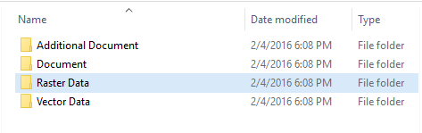
2. | Data naming:  The title of spatial data should represent cut off year, data contents and other information related to LUC analysis. | 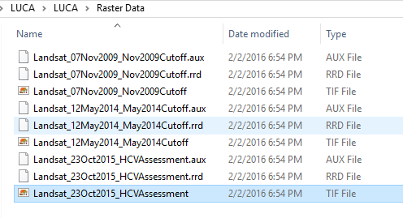  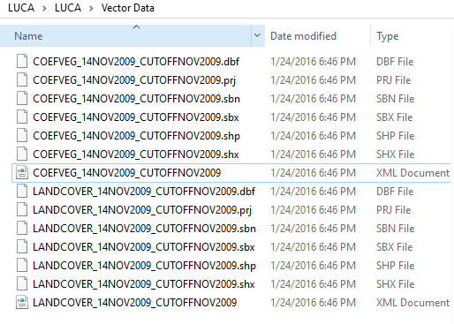
3. | Data attribute information:  All vector data (shp/tab/dwg), should contain information regarding land cover classification such as:  - Land cover class  - Land clearance activity, corporate clearance or non-corporate clearance  - Vegetation coefficient  - Size of each polygon (hectares) | 