ISH CARRY OVER CREDITS FORM

General Information

As part of RSPO’s commitment to supporting the inclusion of Independent Smallholders (ISH), and in line with the announcement published on our website on 1 July 2025, the ISH Carry Over Credits mechanism has been developed to assist ISH groups in requesting an extension for unsold RSPO credits from the previous license period. This form functions as an interim mechanism for the RSPO Secretariat to evaluate such requests in a structured and transparent manner, ensuring that all required information is accurately provided for review and follow-up by the relevant teams, while maintaining the integrity and assurance of RSPO Certification. This form shall be completed and submitted to the RSPO Secretariat by following this LINK.

Unit of Certification Information
Name of Management Unit
(Unit of Certification)
Certificate Number
Certificate Validity | DD MMM YYYY to DD MMM YYYY
Prisma Trading Account ID | TAXX-XXXXXX
Prisma License ID - Previous License | LICXX-XXXXXXXXX
Previous License Validity | Start Date  DD MMM YYYY | End Date  DD MMM YYYY
Prisma License ID - Current License | LICXX-XXXXXXXXX
Current License Validity | Start Date  DD MMM YYYY | End Date  DD MMM YYYY
Current Certification Phase | Please Choose
Number of ISH Members

Summary of Monthly Actual FFB Production*
Month | FFB Volume (MT)
 | Eligibility  (E1) | Eligibility  (E2) | Milestone A  (MS A) | Milestone B  (MS B - IC/RC/ASA)
e.g., 13 - 31 Jan 2024
DD - DD MMM YYYY
DD - DD MMM YYYY
DD - DD MMM YYYY
DD - DD MMM YYYY
DD - DD MMM YYYY
DD - DD MMM YYYY
DD - DD MMM YYYY
DD - DD MMM YYYY
DD - DD MMM YYYY
DD - DD MMM YYYY
DD - DD MMM YYYY
e.g., 01 - 12 Jan 2025
Total (B)
*) Monthly actual FFB production based on the previous license validity.

Terms & Conditions
- Purpose
This Terms and Conditions outline the provisions under which Independent Smallholder (ISH) credits may be carried over from one license period to the next within the RSPO Information System.
- Eligibility Criteria
  - Only RSPO-certified Independent Smallholder Groups under Eligibility, Milestone A, and Milestone B Phases are eligible for carry-over credits.
  - This mechanism applies to all certified ISH groups with unsold credits whose prisma license expired from 1 May 2025 onwards.
  - The ISH group’s certification must remain valid at the time of the carry over request.
  - Credits eligible for carry over are those unsold at the end of the license period based on the actual production.
- Carry Over Limitations
  - Carry-over applies to unsold ISH credits from the immediate previous license period only.
  - Credits may only be carried over once; no further extensions or second carry-overs are permitted.
  - Carried-over credits shall remain valid for a maximum period of 12 months or until the next license end date, whichever comes first.
- Conditions of Use
  - Carried-over credits shall be subject to the same trading rules as new credits.
  - Failure to sell carried-over credits within the allowed 12-month period or until the end date of the next license will result in their expiry and removal from the account.
  - No refunds, replacements, or further extensions shall be granted to the Carried-over credits.
- Compliance and Breach
Any misuse, misrepresentation, or fraudulent activity related to credit carry-over will result in a deduction of the certified volume for the next license period by the Certification Body.
- RSPO Rights
RSPO reserves the right to:
- Amend these Terms and Conditions at any time.
- Decline any carry-over request should it be found that the ISH Group does not meet the eligible criteria.
- Acceptance of Terms
By submitting a carry-over request, the ISH Group acknowledges and accepts these Terms and Conditions.

ISH Declaration

Signing by the Independent Smallholder Group
I, the undersigned, acting as the authorised representative of the Independent Smallholder Group, performing the ISH Carry Over Credits, hereby formally acknowledge and further affirm the following:
- Acknowledge, understand, and agree to comply with the Terms and Conditions for Independent Smallholder (ISH) Carry Over Credits, as issued by the RSPO Secretariat.
- Acknowledge that RSPO reserves the right to review, amend, or revoke the carry-over at its sole discretion.
Name
Position
Contact email
Signature
Date | DD MMM YYYY

- Data Facilitation from the Smallholder Unit

The RSPO Smallholder Unit has performed the data consolidation of the ISH Carry Over Credits form, hereby formally acknowledges and further affirms the following:
- The verification of the submitted ISH Carry Over Credits Form has been conducted.
- All necessary supporting documentation from the Independent Smallholder Group has been reviewed and confirmed to be complete and accurate at the time of verification, to the best of my knowledge.
- The requesting Independent Smallholder Group holds a valid RSPO certification and meets the eligibility criteria for credit carry-over as outlined in the Terms and Conditions for ISH Carry Over Credits.
Name
Position
Contact email
Date | DD MMM YYYY

Version: 1.1
Date: 14 Aug 2025

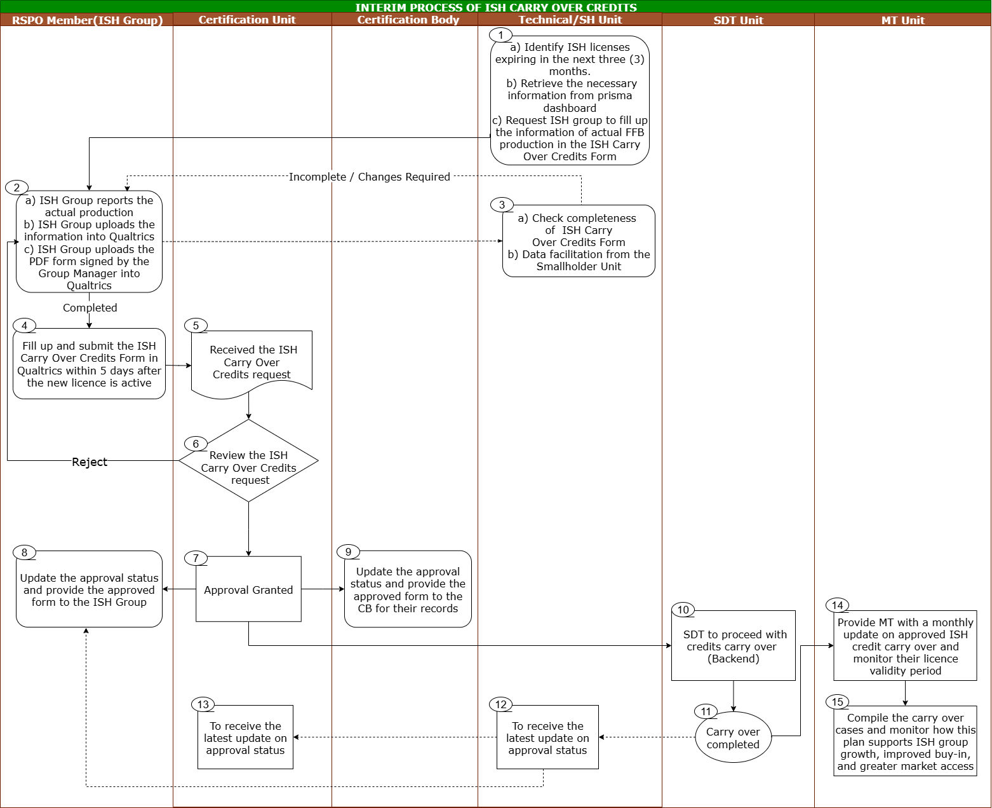
Annex 1: Flowchart of the Interim Process of ISH Carry Over Credits (Off-Platform)

Version: 1.1
Date: 14 Aug 2025

